**Model Development Phase Template**

|  |  |
| --- | --- |
| Date | 12 November 2024 |
| Team ID | team-739757 |
| Project Title | Tomato Plant Disease Detection From Leaf Images using DeepLearning |
| Maximum Marks | 10 Marks |

**Initial Model Training Code, Model Validation and Evaluation Report**

The initial model training code will be showcased in the future through a screenshot. The model validation and evaluation report will include a summary and training and validation performance metrics for multiple models, presented through respective screenshots.

**Initial Model Training Code (5 marks):**

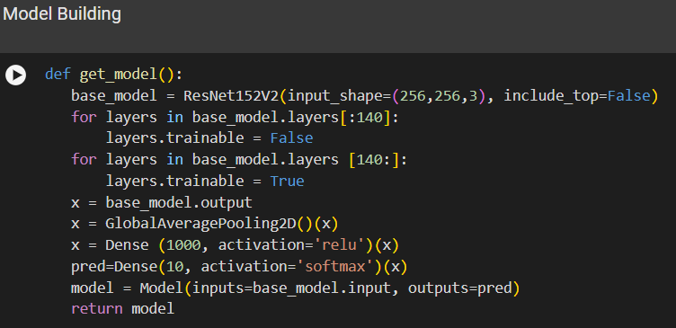

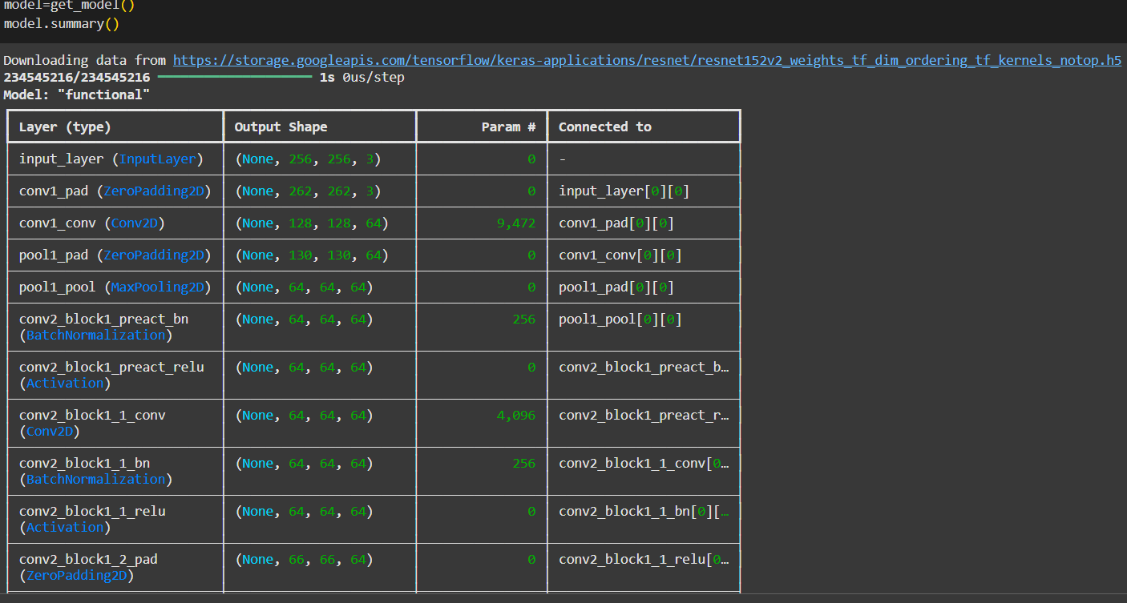

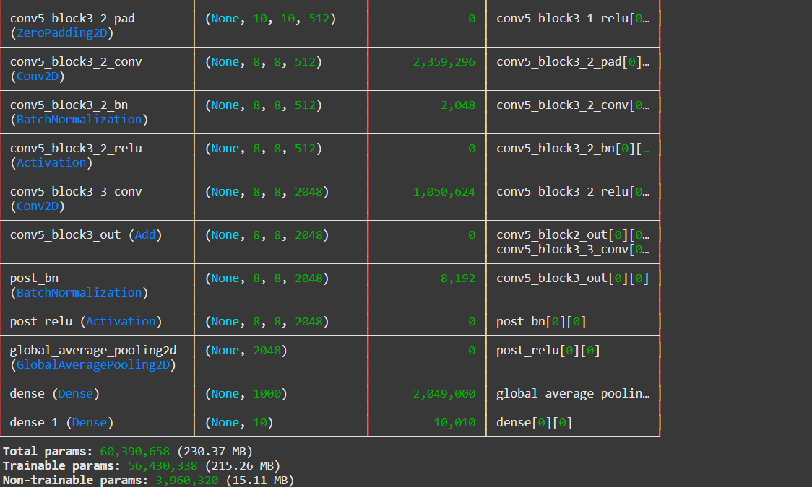

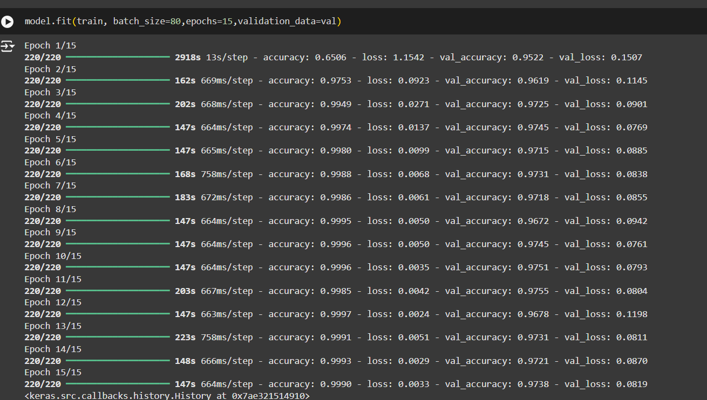

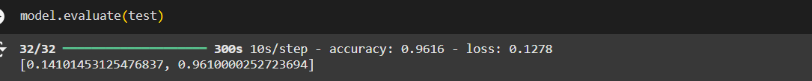

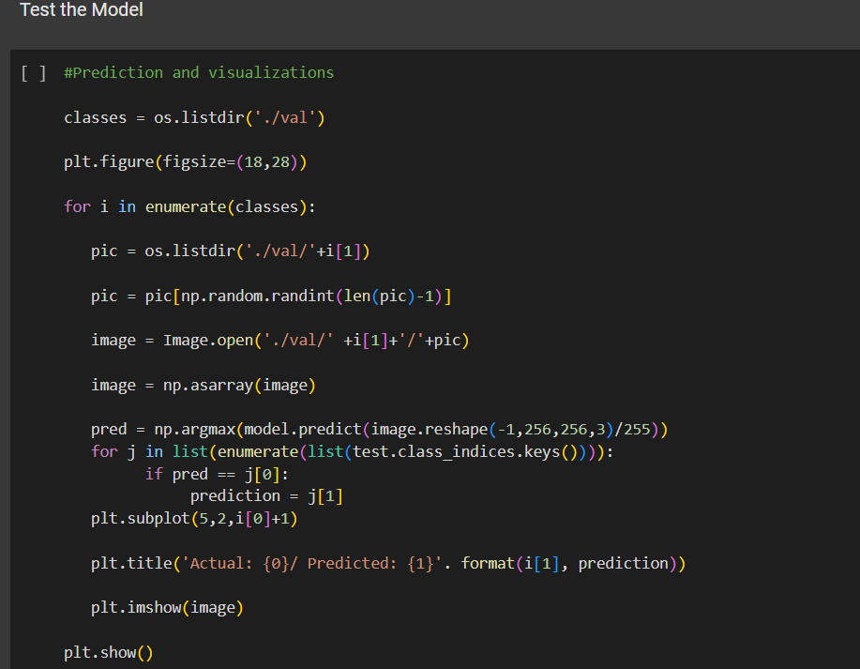

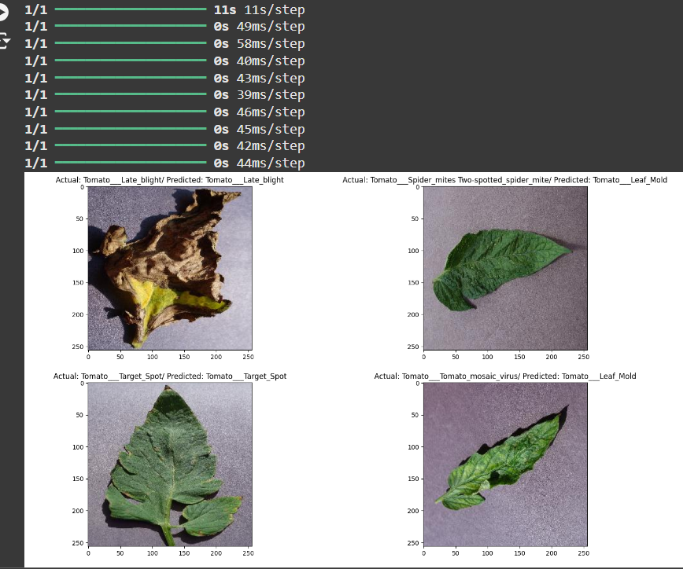

**Model Validation and Evaluation Report (5 marks):**

|  |  |  |
| --- | --- | --- |
| **Model** | **Summary** | **Training and Validation Performance Metrics** |
| ResNet152V2 | The ResNet15v2 model achieved excellent performance for tomato plant disease detection, with a final training accuracy of 99.9% and validation accuracy stabilizing around 97.3%. The training and validation losses consistently decreased, ending at 0.0033 and 0.0819, respectively, indicating strong convergence and generalization. Each epoch processed efficiently within 147–223 seconds, showing computational efficiency. Overall, the model is highly effective and well-suited for accurate and reliable tomato plant disease detection. |  |